## Recap

There are many challenges to meet mobile data growth. Spectral efficiency, size of communication channel need to be increased more base station need to be deployed. Different wireless technology requires separate channel for itself, therefore governing authority plays a vital role for allocating spectrum. The most popular networking techniques are Frequency Division Multiplexing (FDD) and Time Division Multiplexing (TDD). FDD need to have separate channel for up and down link but TDD handle that via one channel.

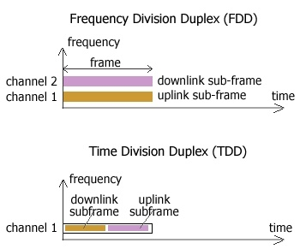

Figure 1. TDD & FDD

Mostly any country's local authority offer TDD or FDD. In Europe and USA it is predominantly FDD, but there are some TDD trials but in China mostly TDD. China Mobile activated trial 4G Time Division Long Term Evolution (TD-LTE) networks in Hangzhou and Wenzhou city. The Hangzhou network comprises 2,400 base stations, covering 500 square kilometres for around five million people. As of 2014, there are 235 LTE FDD networks, 15 LTE TDD networks and 13 LTE FDD&TDD networks worldwide. LTE-U has become the discussion topic in the whole industry by allowing deployment of LTE pico/femto cells in the unlicensed spectrum.

Operators may not have available spectrum in the same band sometimes or allocated scattered into several chunks for them. Operators may intentionally go for spectrum in different bands for taking full benefit of spectrum , for example, low bands for coverage purposes and high bands for capacity. If we observe HSPA and LTE bandwidth adaptation, in HSPA the basic building block is 5MHz for each carrier, max 8 carriers can be aggregated. On the other hand LTE's basic building block is a carrier, which can vary from 1.4 to 20 MHz with max 5 carriers.

## Problem

I think FDD and TDD could have elaborated more from technical point of view, how they are carrying signals. Was very keen to get some info about MIMO technique. And macro, micro, pico, femto concept was not clear that much by one pictorial depiction.

## Criticism

Nowadays regulatory authority arrange bidding for country’s auction of third / fourth-generation spectrum. But often price go so high that small company cannot afford and get out of the market, it need to be handle in a safe way to make balance among competitors. In developing world regulatory authority often give spectrum segment to a authority who is not authorized for that segment according ITU, for example "Amateur Radio Operator's" allotted band often occupied by other wireless operator.

## Deepening

Popularity of smartphones and Internet-based mobile services is boosting up therefore, data usage is skyrocketing on wireless networks. Competition is intensifying among carriers, who are pursuing strategies that boost capacity and slow down expenses, so they are shifting away from big and expensive big size service tower. By following cell phones what are getting smaller, less expensive and more capable; cell tower are getting smaller and cheap to reduce costs and speed network expansion. These include micro cells, pico cells and femto cells. Different cell's covering size is following

* Macro cell 1 - 5 Km long
* Micro cell 100 - 500 Meters
* Pico cell 10-80 meters
* Femto is indoor, homes .

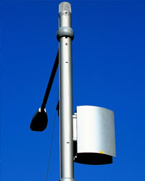

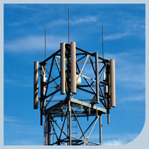

femtocell handheld cell site Picocell in an office Micro cell at street Macro cell at field

Khandker, Syed Ibrahim

WISE